Spooky Read Night
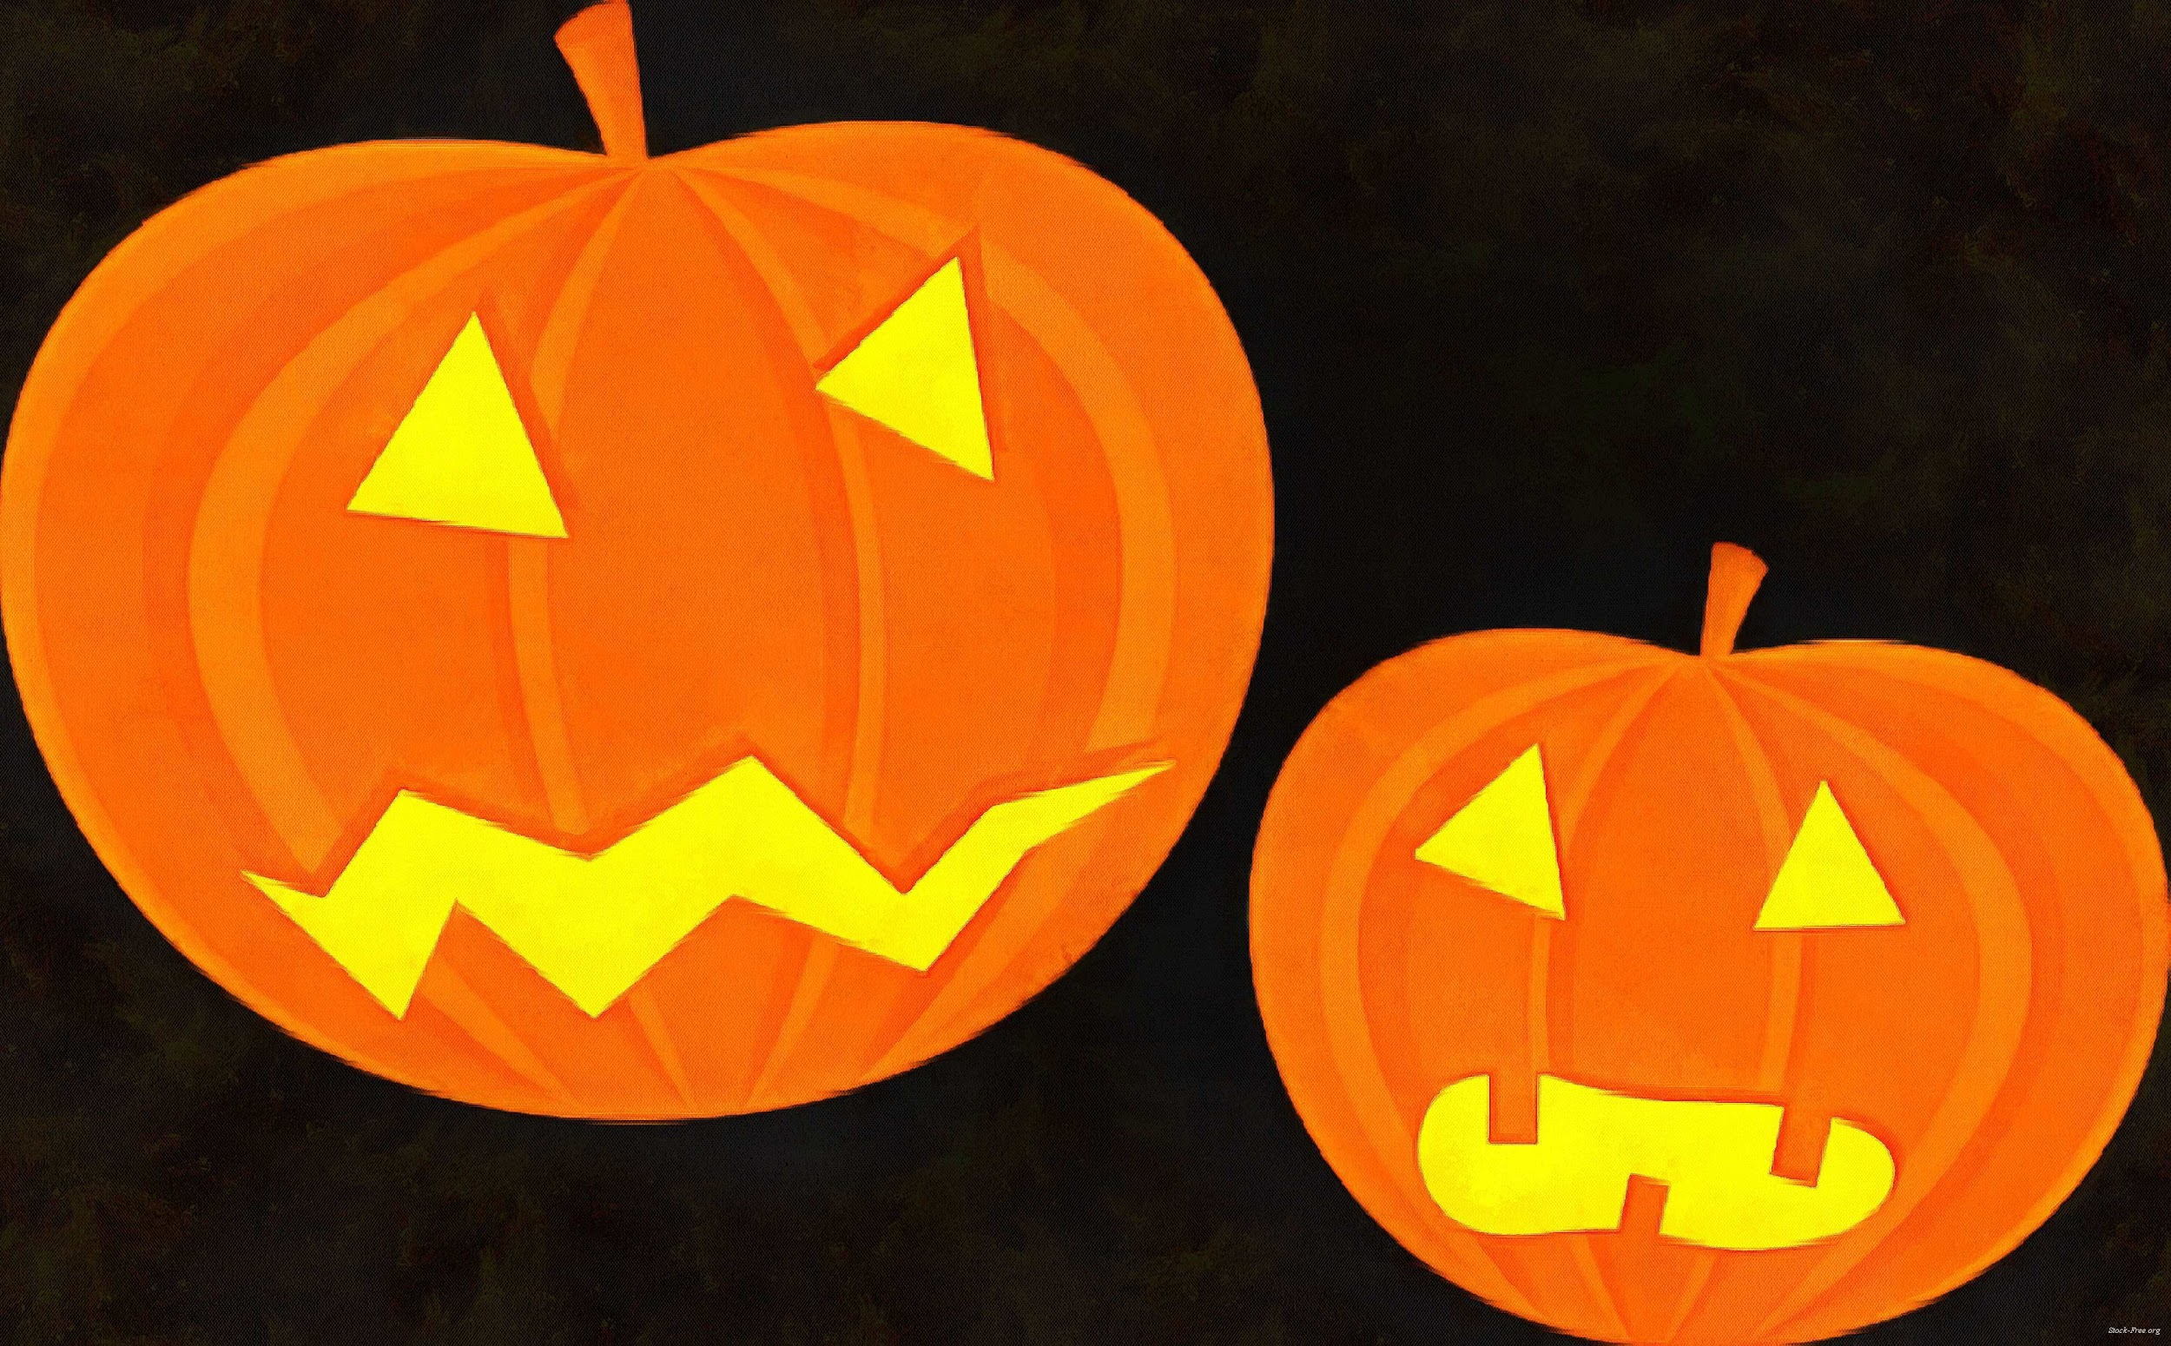

WHO: McVay Families

WHAT: Food Trucks (5:00-8:00)
Activities (6:00-7:30)
Spooky Parade (7:30-8:00)

WHERE: McVay Elementary

WHEN: Monday, October 28 from 6:00-8:00 p.m.

WHY: To enjoy a good time with family and friends!

The children may dress up for Spooky Read Night. They will get to show off their costumes during our parade at the end of the event. All costumes need to be appropriate for the school function. NO masks, swords, guns, or any other items that represent a weapon. Thank you!

Reminder…All children need to be supervised by a parent or guardian. McVay staff and PTA are NOT responsible for any children at the event. Thank you for your support!
Food Trucks

Dane´s Dogs
Totally Baked

Activities

Stories
Face Painting
Photo Booth
Book Fair
Sensory Room
Dancing

Spooky Parade

Each child will receive a small treat bag filled with Smarties and DumDums.

WARM Donation

Canned fruit, potatoes, spinach, beets, and lima beans
Mayonnaise
Flour
Sugar

THANK YOU to our sponsor:

